Ulvi Bajarani

SID 20539914

CSCI 6345 – Advanced Computer Networks

Summer II

Assignment 3

The file sharing between Windows computers with NET commands

1) In the first steps, we install the Windows to the Virtual Machine. Since that the author could not connect to the internet by Windows 7 SP1, for the assignment, Windows 8.1 Professional was used. Starting the next page, the installation steps are provided.

After choosing proper languages, “Next” is clicked:

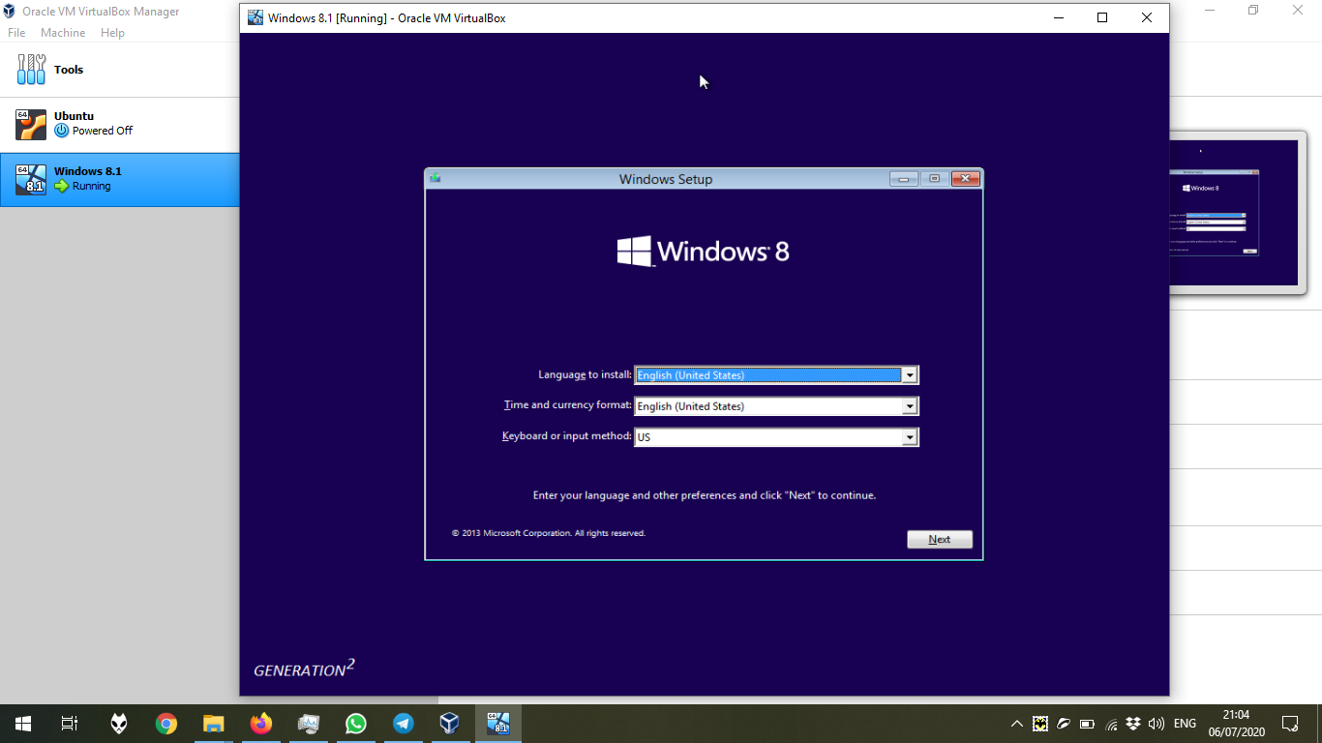

Then, “Install now” is clicked:

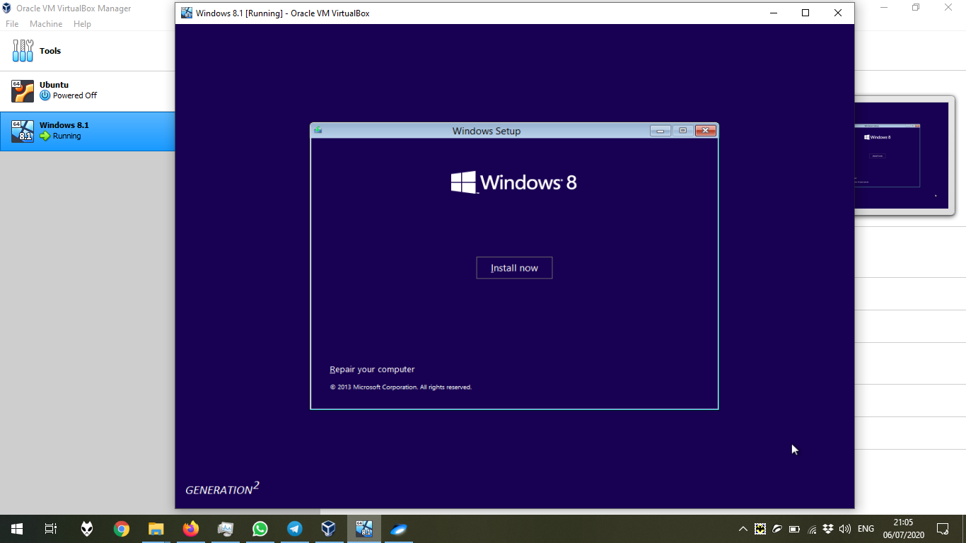

Then, we should choose the proper version. For managing group policies, it is important to install Pro version, which is done.

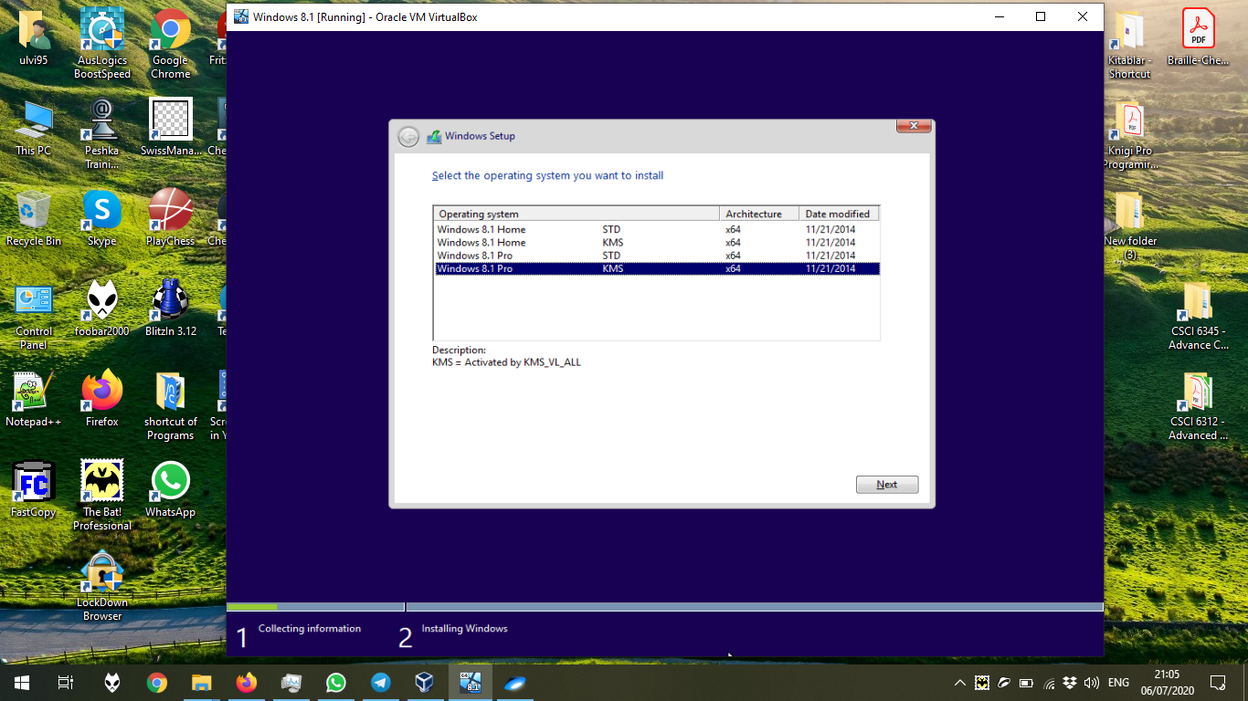In the next step, we should choose if we upgrade the system or install the new one. If we install the new one, we choose “Custom”

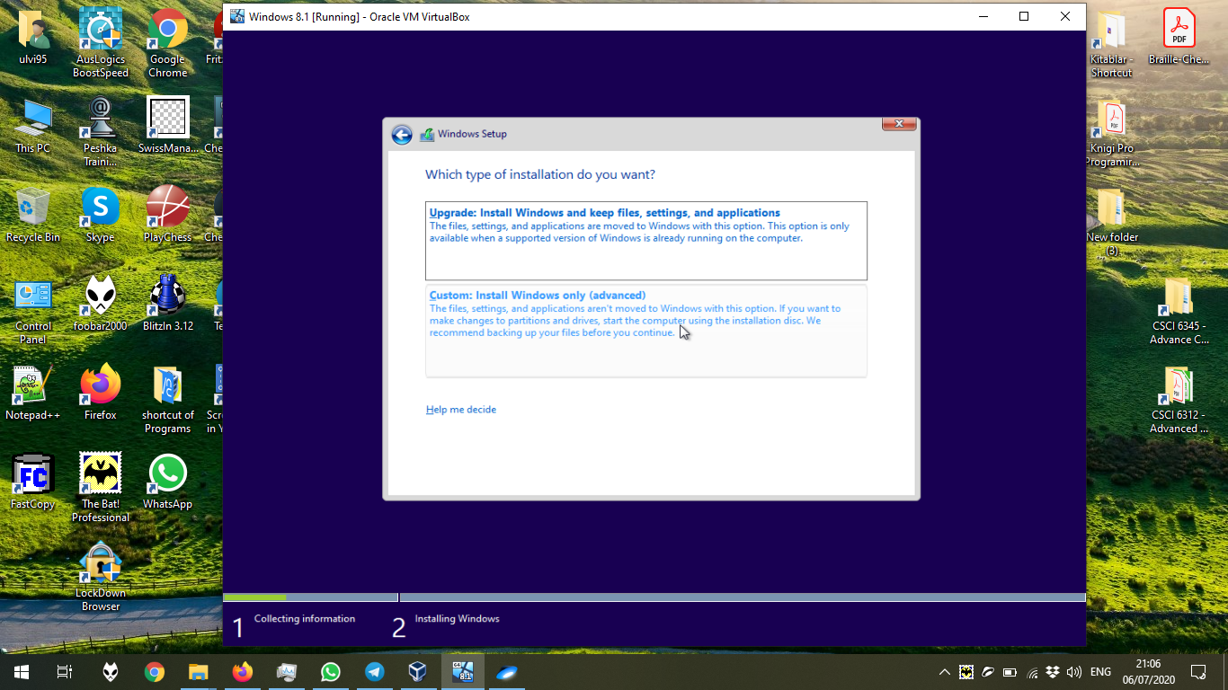

And finally, we choose the disk. If it is not empty, it should be formatted before installation:

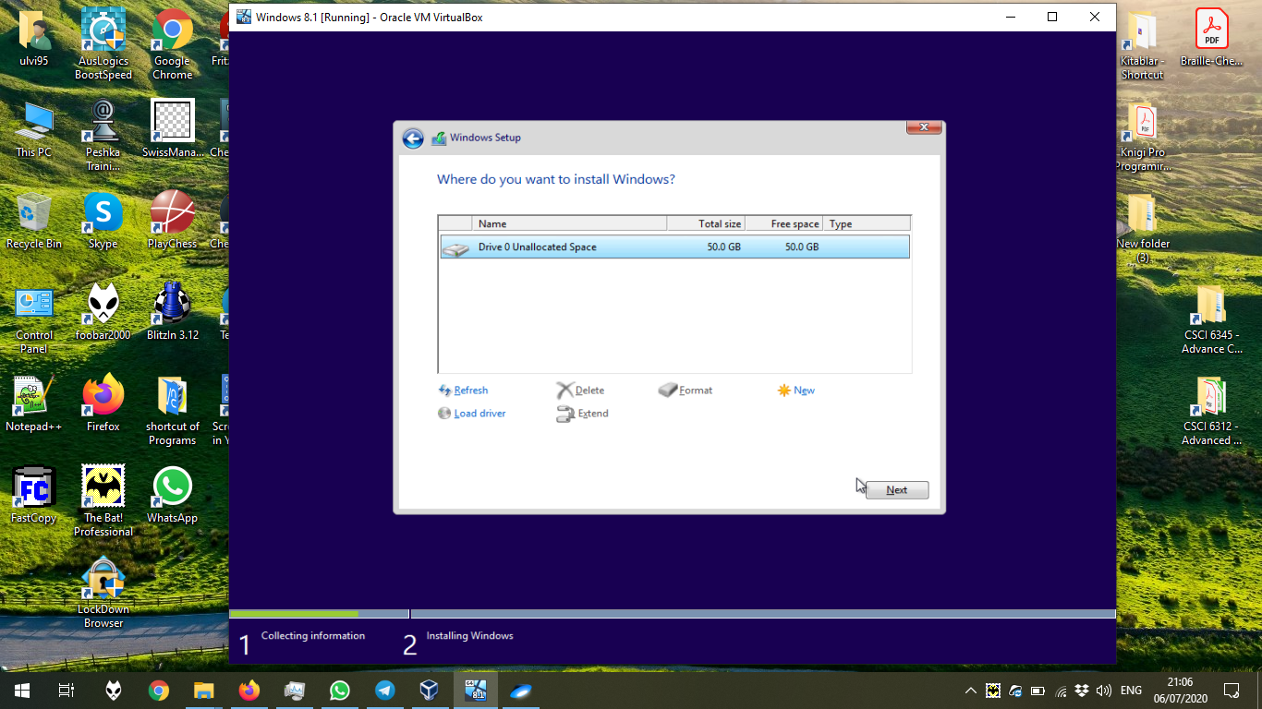

The installation process is in the progress:

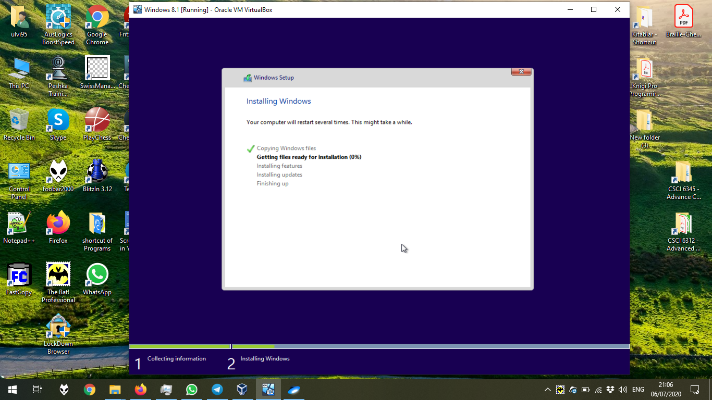

The screen after the personalizing steps and the internet connection:

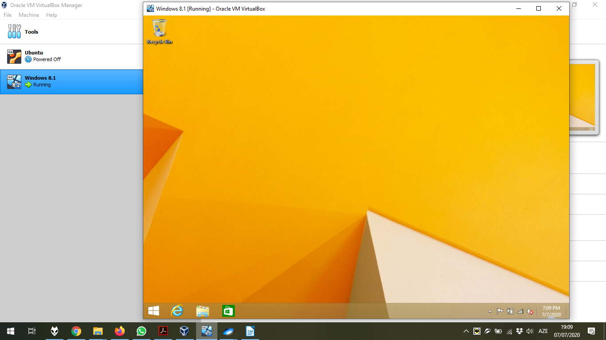

2) Let’s open Command Prompt with Administrator Rights and test the NET commands.

The execution of **NET ACCOUNTS**, **NET COMPUTER**, and the **NET CONFIG** commands.

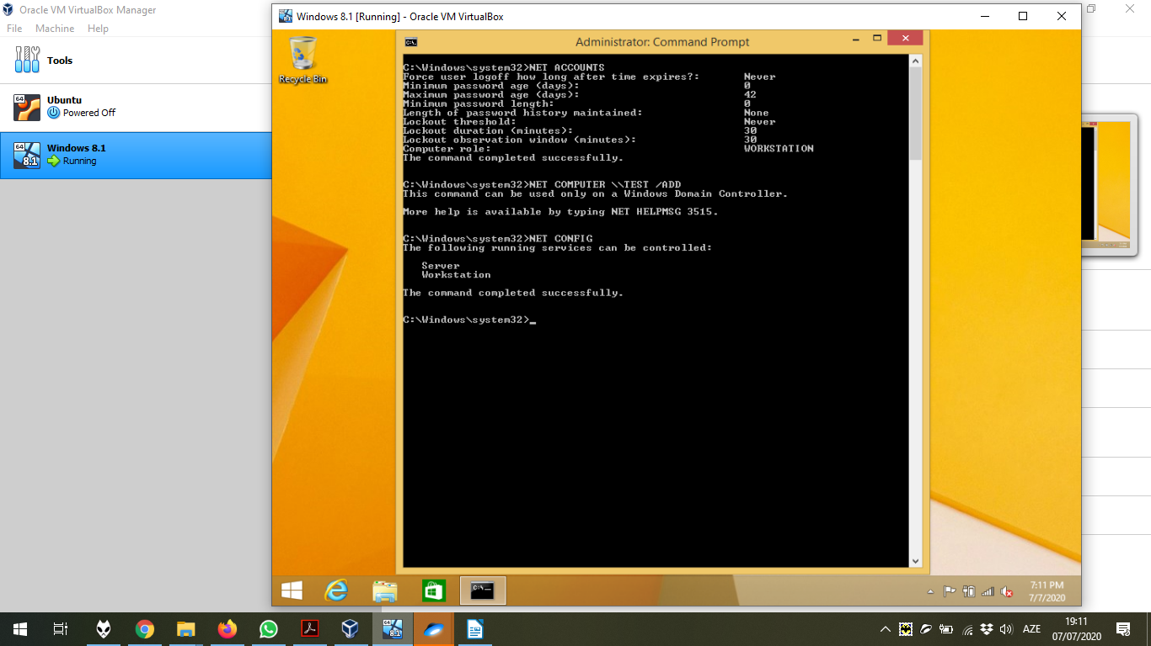

The execution of **NET STOP**, **NET START**, **NET PAUSE** and the **NET CONTINUE** commands.

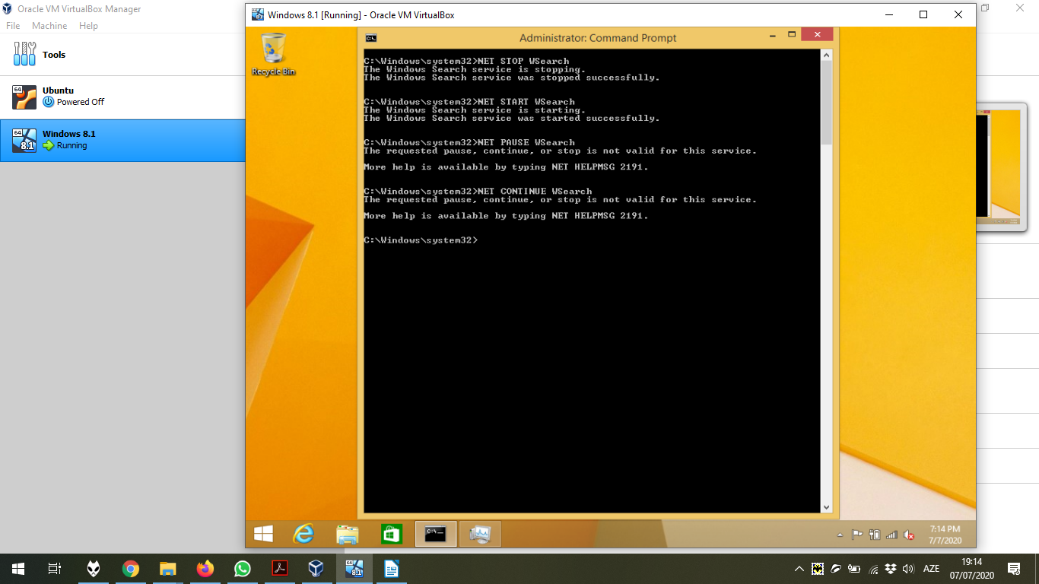

The execution of **NET FILE**, **NET GROUP**, and the **NET HELP** commands.

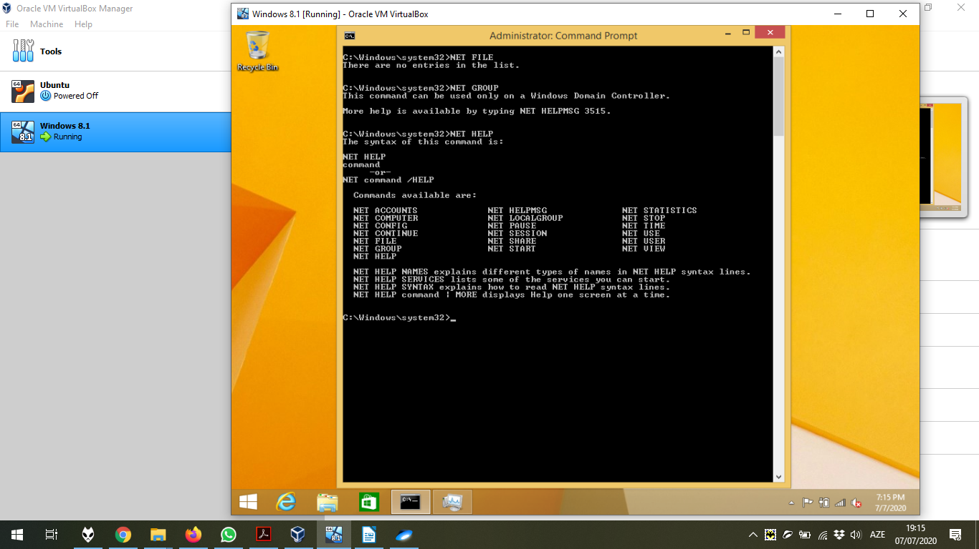

The execution of **NET HELPMSG**, **NET LOCALGROUP** commands.

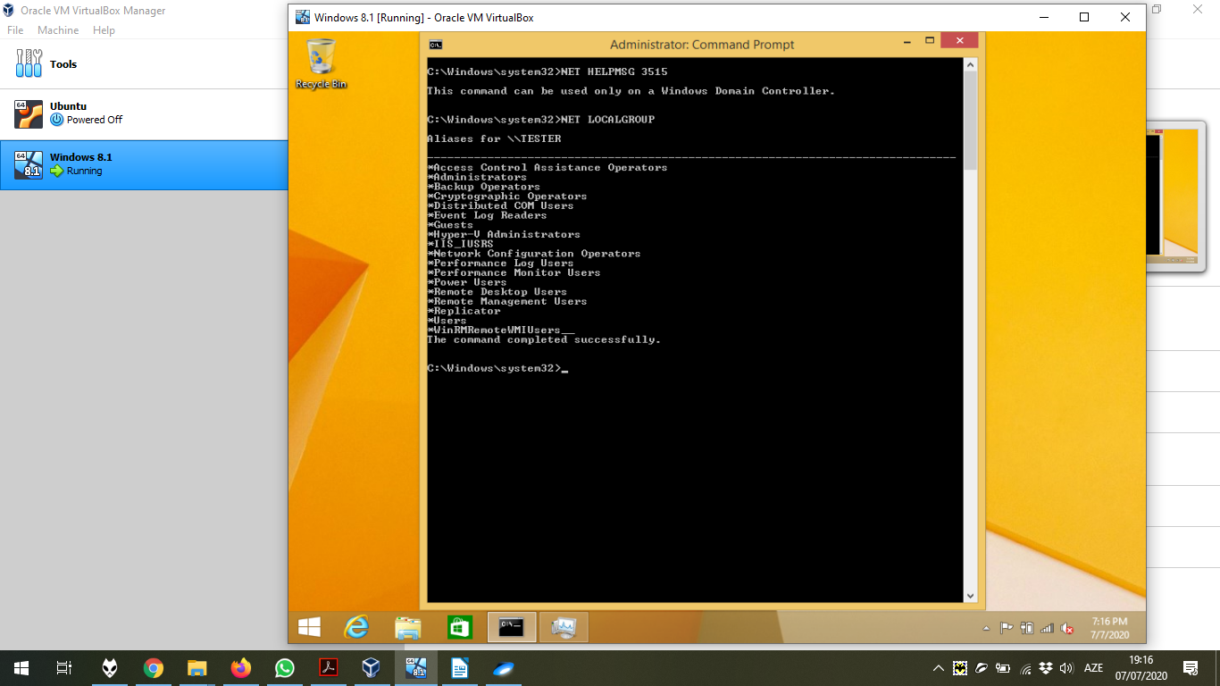

The execution of **NET SESSION**, **NET SHARE** commands.

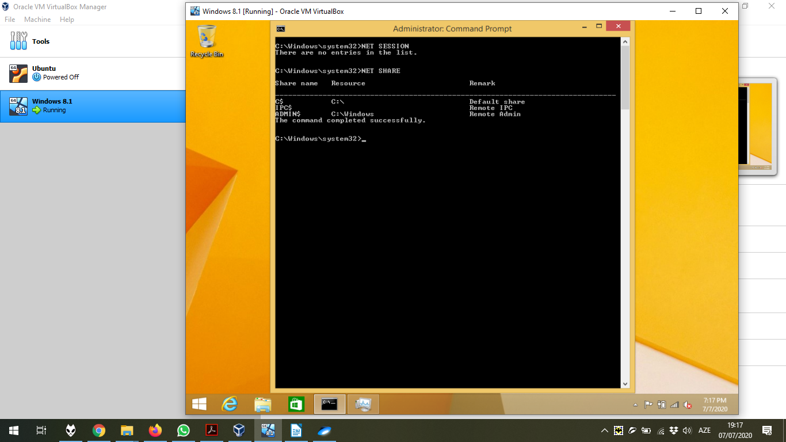

The execution of **NET STATISTIC** commands.

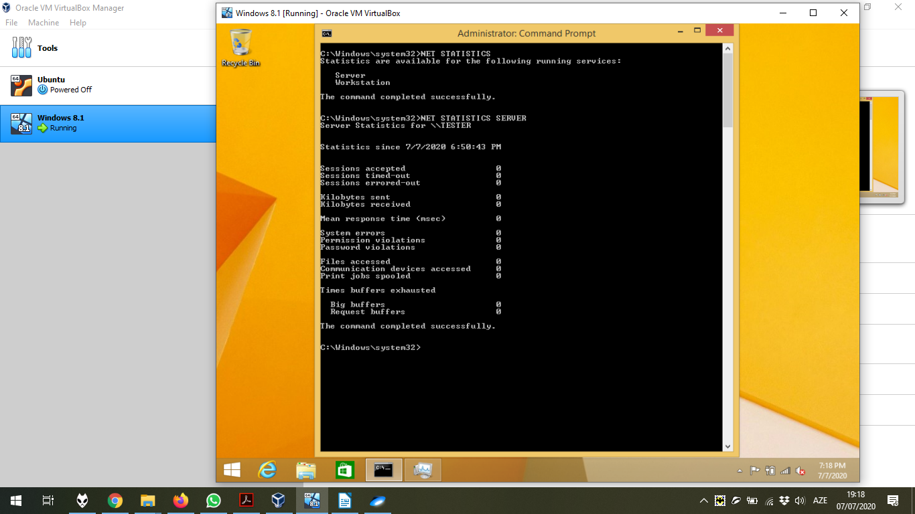The execution of **NET TIME**, **NET USER**, **NET VIEW**, and **NET USE** commands.

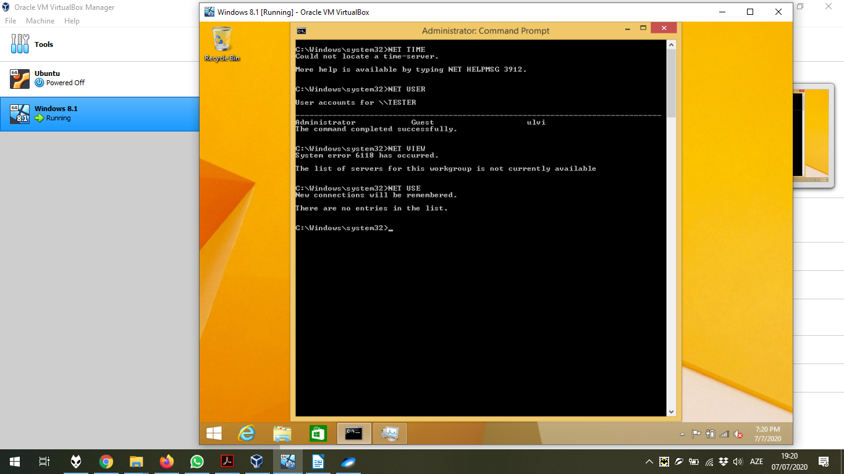

3) Now, let’s share the folders using NET commands from the Host by the Command Promt with Administrator Righ. It is done by **net share sharedOfficeHost=C:\Users\ulvi95\Desktop\test /grant:everyone,FULL**

Where

* **sharedOfficeHost** is the name of folder in the share;
* **C:\Users\ulvi95\Desktop\test** is the directory of our folder, which is immediately after **=** sign;
* **/grant:** describes the granted user group. In our case, it is **everyone**;
* **FULL** is the permission rights.

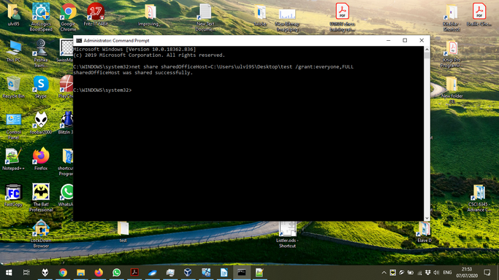

It is important to have everyone in the group of folder or user names in the Properties → Security. Otherwise, it will be impossible to enter to the folder. Also, network sharing should be turned on.

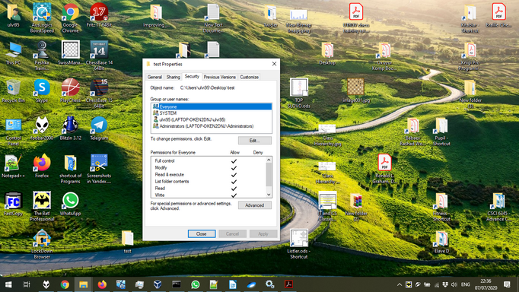

Now, let’s open sharedOfficeHost folder from the Guest. It is done by **//<Name of the Computer>/sharedOfficeHost** in the **Run** program of the Guest. After that, I opened the text file, which might be seen.

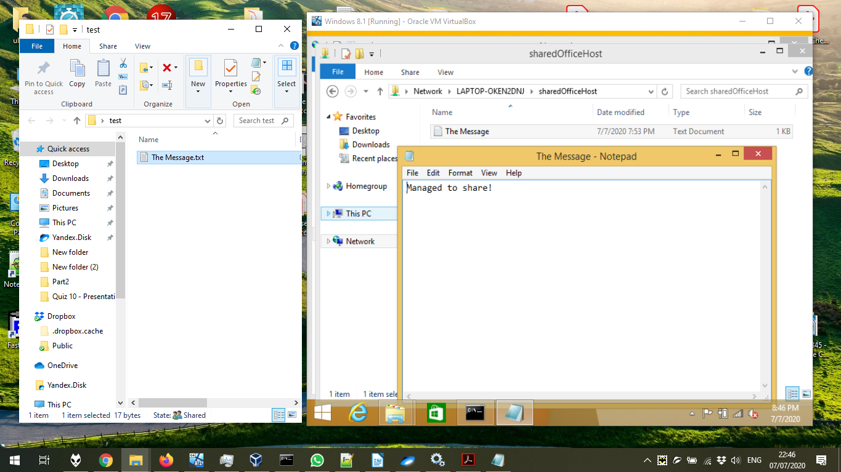

Let’s do this from the Guest with another folder by **net share sharedOfficeHost=C:\Users\ulvi\Desktop\testVirtual /grant:everyone,FULL** command.

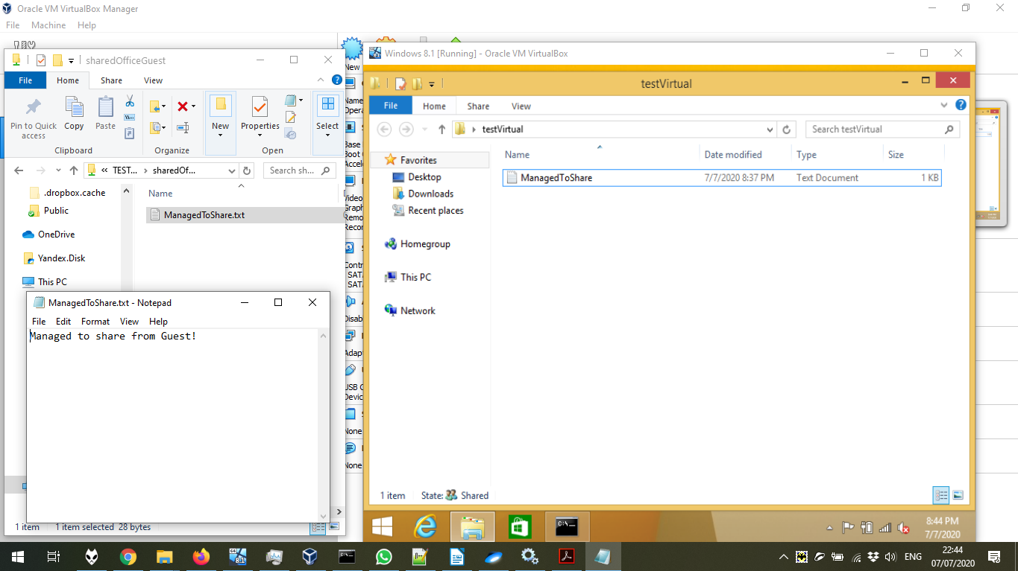

In the next screenshot, just the proof of the sharing: both folders can be seen in the network:

